SQL - Question -3

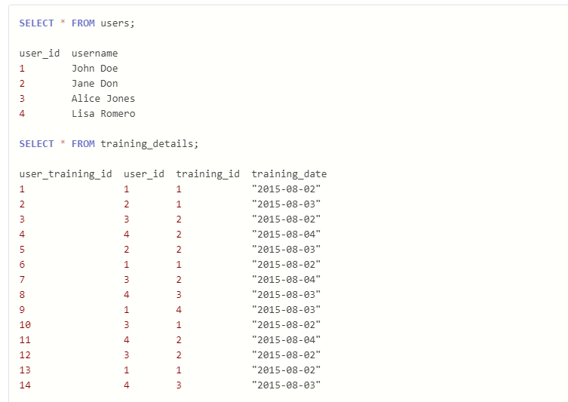

Write a query to to get the list of users who took the a training lesson more than once in the same day, grouped by user and training lesson, each ordered from the most recent lesson date to oldest date.

Answer –

SELECT u.user_id, username, training_id, training_date

FROM users u

INNER JOIN training_details td ON u.user_id = td.user_id

GROUP BY u.user_id, username, training_id

HAVING COUNT(td.user_training_id) > 1

ORDER BY u.user_id, training_date DESC;